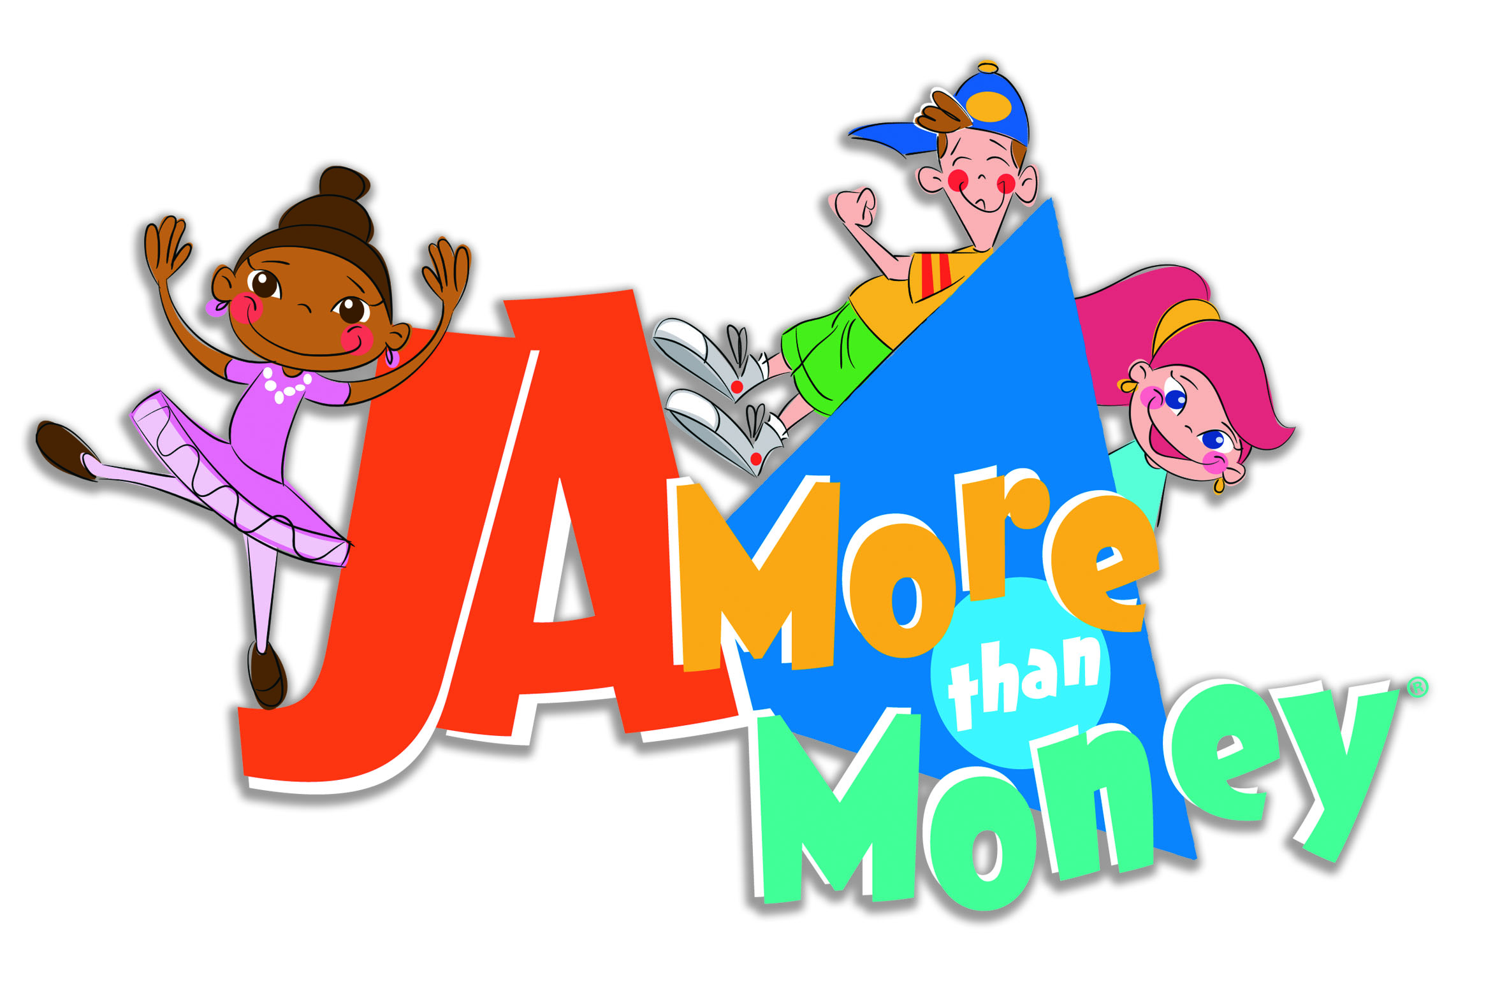
HSBC Global Initiative:
JA More than Money®

For many Junior Achievement volunteers, the initial anxiety of standing before a classroom of students is more than rewarded by the students’ gratitude. Such inspirational appreciation often motivates volunteers return to the classroom again and again.
At the conclusion of a recent JA class, the students presented the JA volunteer with thank-you cards they created.

One student wrote: “You are the best Junior Achievement teacher we have ever had. You taught us a lot. Our brain is filled with knowledge. Before you started, our brains were small. After you finished they were large.”

Another student wrote: “Thank you for giving us knowledge, for in the future, we will now know everything.”

A third student wrote: “Thank you for all the wisdom you have gave us.” The thank-you note included the following illustration:

The Brain: Before Junior Achievement – 30 percent
After Junior Achievement – 100 percent

Finally, one student recapped the experience this way: “Thank you because you taught me a lot with money. So if I have money or, have a job, I now know everything.”

Nothing sums up the value of JA better than our students!

To our friends at HSBC, we are thrilled to share with you that we are well on our way to reaching our Year 5 goal. So far, 66,343 students have participated in JA More than Money this year, thanks to volunteers like you.

The collaboration between Junior Achievement and HSBC spans across 31 countries. Students benefit by receiving important financial literacy education and the skills they need to be financially astute adults.

But how do HSBC volunteers benefit?

When you deliver JA More than Money to students in your community, you:

- Can hone your presentation skills in front of a friendly audience
- See impact of JA More than Money first-hand through the students’ comments, questions and smiling faces
- Contribute to the financial health of your community on behalf of HSBC
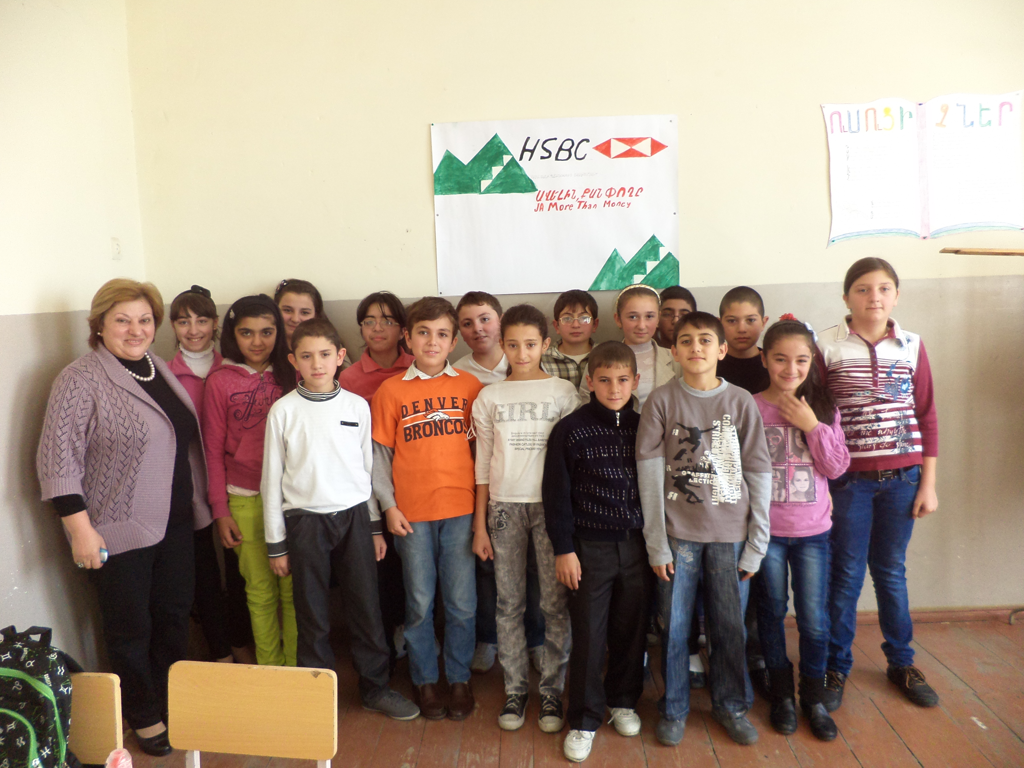

Number of HSBC volunteers - 12. Number of students – 1500.
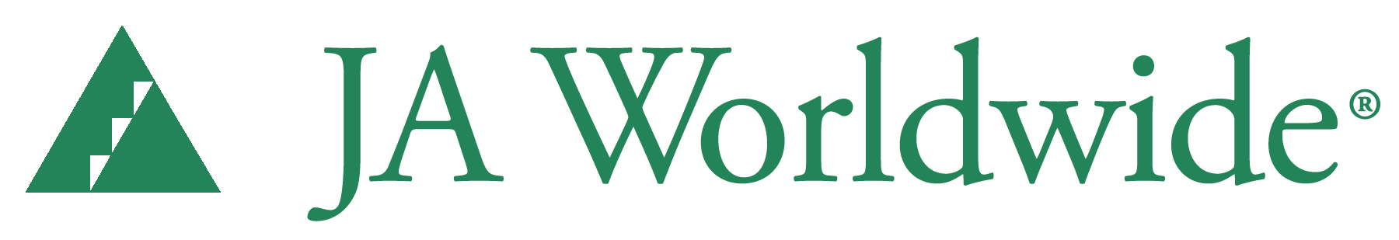Click www.jaarmenia.org to learn more about JA More than Money volunteer opportunities in your area.

